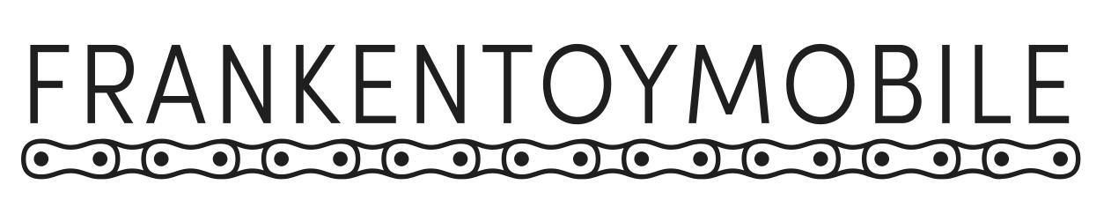

The FrankenToyMobile is rolling out for another year of encouraging imagination and curiosity through creative reuse!

June 2016, Chicago, IL – The FrankenToyMobile is gearing up for its second summer of offering free, hands-on workshops around Chicago to encourage imagination and creative experimentation.

Created by artists Andrés Lemus-Spont and Marya Spont-Lemus in collaboration with Louis Fernandez and Michael Pecirno, the FrankenToyMobile is a pedal-powered maker space that provides free, hands-on workshops where youth and adults re-use toys as raw material for original creations. Since the project launched in June 2015, the FrankenToyMobile has served over 1,700 people through 20 workshops in public spaces around Chicago, with a focus on the South and Southwest sides.

In a custom vehicle designed and built by Lemus-Spont, this traveling studio enables the project to go to people, lowering barriers to access and turning public spaces into opportunities for community-based creative experiences. At each FrankenToyMobile event, participants are provided with minimal directions: grab a tray, select toy parts, and decide what they want to make. Teen workshop facilitators support participants’ creative process as needed, teaching sewing and other fastening skills and serving as technical assistants to help make participants’ visions reality. This project is as much about bringing people together to share creative experiences and discover new talents as it is about the toys that are made.

The FrankenToyMobile already has nearly 20 more events planned for this coming summer, through which it hopes to reach even more participants. Through partnerships with the Chicago Park District’s Night Out in the Parks*, Activate! with Latent Design, and the Chicago Public Library, the FrankenToyMobile will deepen relationships with communities served in its inaugural year while expanding its reach to new communities. The FrankenToyMobile is partially supported by a 2016 Individual Artist Program Grant from the City of Chicago Department of Cultural Affairs & Special Events (DCASE), as well as a grant from the Illinois Arts Council, a state agency through federal funds provided by the National Endowment for the Arts.

The FrankenToyMobile also benefits from generous donations of secondhand toys from both individuals and organizations like Unique Thrift Store. As project co-creator Lemus-Spont describes, “There is also such an overabundance of toys in our country, so many of which end up in garages and trash bins. I think we help reshape conceptions around usefulness and value by casting a new light on those toys.”

Beyond environmentalism and creative re-use, recycling toys to make new toys is an exercise in both imagination and choice. By providing youth, in particular, an opportunity to modify “junk” toys into objects that they feel express their identity and personality, the project intends to encourage its participants to challenge dominant ideas about gendered toys. The FrankenToyMobile team is especially concerned with the impact that toys can have on the interests, goals, and future careers of young girls, and the project aims to prompt thinking and conversation about what we learn from mass-produced objects and culture.

Throughout this work, the FrankenToyMobile endeavors to inspire participants to not simply accept what is given to them but to open their minds to the possibility of change, large and small. “How better to re-think the world than to re-make it?” Spont-Lemus asks.

A full listing of confirmed workshops is available at www.frankentoymobile.com.

* The FrankenToyMobile is presented as part of the Chicago Park District’s Night Out in the Parks series, supported by Mayor Rahm Emanuel. Arts programming in neighborhoods across the city advances the goals of the Chicago Park District and the Chicago Cultural Plan. Now in its fourth year, the 2016 Night Out in the Parks series will host over 1,200 cultural events and programs at more than 250 neighborhood parks throughout the city, making community parks a safe haven and hubs of activity. Projects will vary from traditional performances and concerts, to movies, peace rallies, community workshops, nature based programs, dance pieces, festivals, and more. The Chicago Park District has partnered with more than 120 arts and community organizations to expand and produce this successful initiative. For more information about Night Out in the Parks, please visit www.nightoutintheparks.com.

Photos
For high-resolution images and more information, please visit www.frankentoymobile.com/press.

Contact
Marya Spont-Lemus, info@frankentoymobile.com

